Assignment Report

Advanced Programming (6G5Z1101)

**Pritam Sangani (16039231)**

# Successful Implementations

All handlers for the Student Web Service were implemented successfully, with the retrieval of all Students, as well as individual Students, being GET requests and the rest of the handlers implementing POST requests. Screenshots are included below to evidence the successful implementations.

## Retrieve all Students from the Database

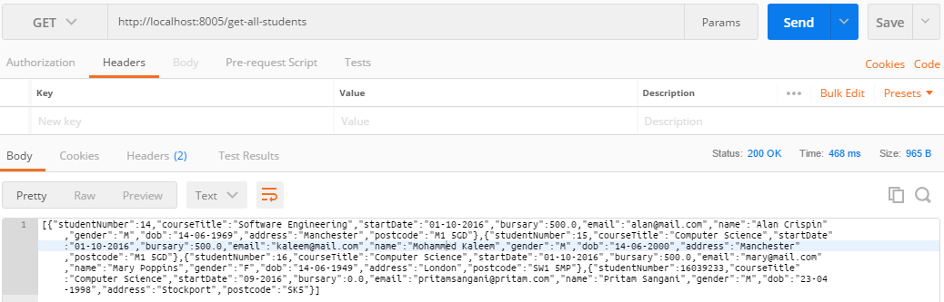

## Insert Student into Database

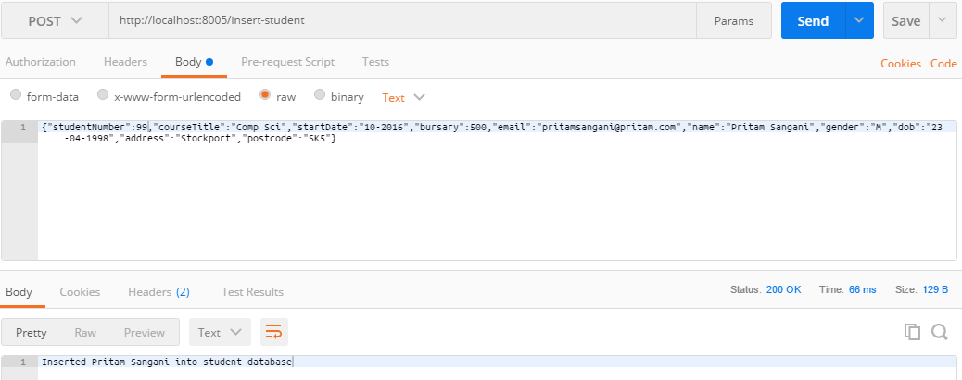

## Delete Student from Database

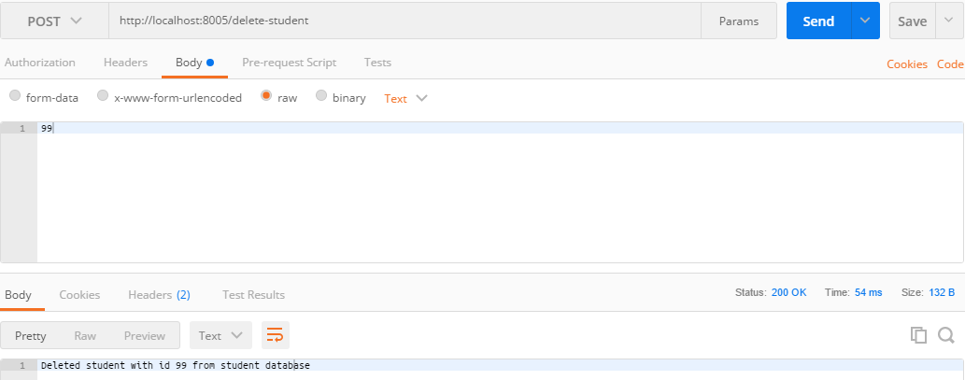

## Update Student currently in Database

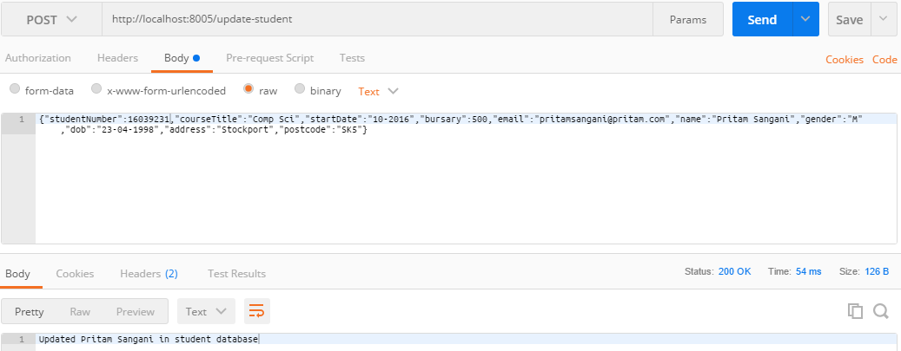

## Retrieve an individual Student from the Database

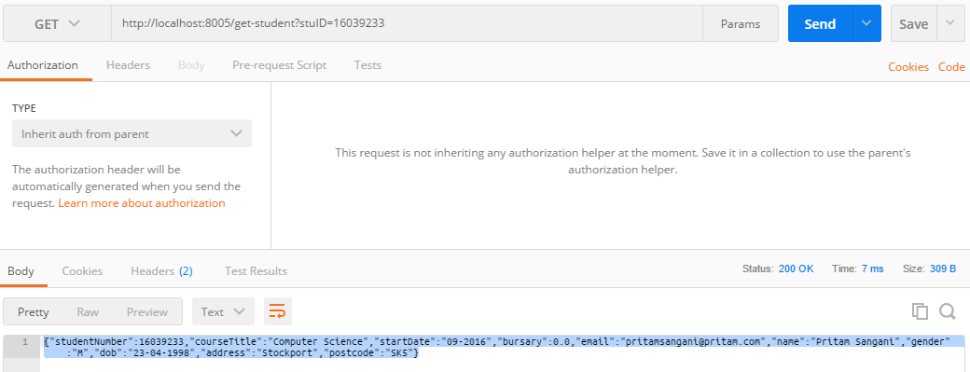

Completed features are inside the red box

